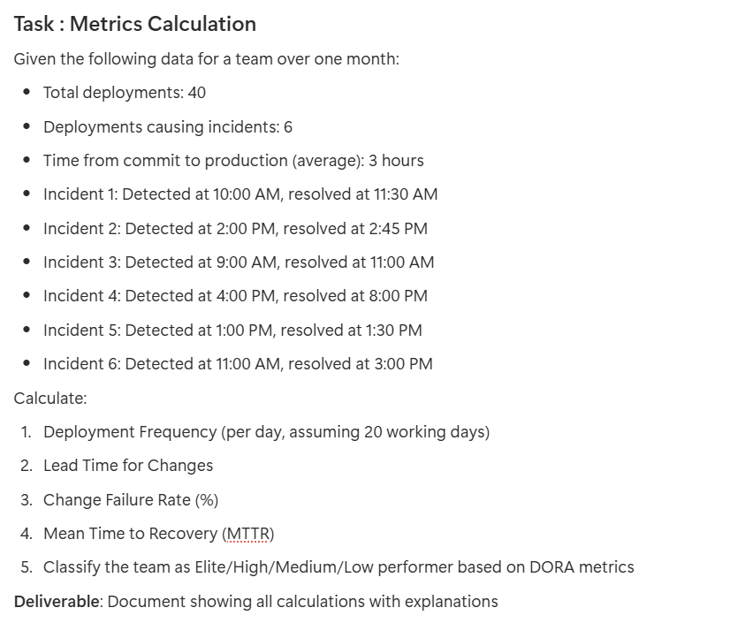
DORA Metrics Calculation
1. Deployment Frequency (per day)
Deployment Frequency = Total Deployments / Working Days
Calculation:
40 deployments / 20 days = 2 deployments per day
Answer: 2 deployments/day

2. Lead Time for Changes
Given:
Average time from commit to production: 3 hours
Answer: 3 hours

3. Change Failure Rate (%)
Change Failure Rate = (Failed Deployments / Total Deployments) × 100
Calculation:
(6 / 40) × 100 = 15%
Answer: 15%
4. Mean Time to Recovery (MTTR)
First convert all incident durations to hours:
Incident 1: 1.5 hrs
Incident 2: 0.75 hrs
Incident 3: 2 hrs
Incident 4: 4 hrs
Incident 5: 0.5 hrs
Incident 6: 4 hrs
Sum of all incident durations:
1.5 + 0.75 + 2 + 4 + 0.5 + 4 = 12.75 hours
Formula:
MTTR = Total Incident Duration / Number of Incidents
Calculation:
12.75 hours / 6 incidents = 2.125 hours
Converted:
2.125 hours = 2 hours 7.5 minutes

5. DORA Classification
Based on standard DORA ranges:
Deployment Frequency:
2/day → Elite
Lead Time for Changes:
3 hours → Elite (<1 day)
Change Failure Rate:
15% → Medium (Elite < 15%, High 15–30%) → Borderline
Mean Time To Recovery (MTTR):
~2 hours → Elite (<1 hour) or High (<1 day)

Final DORA Classification
The team mostly matches Elite performance except:
CFR = 15% → falls into High/Medium boundary
MTTR slightly above elite (<1 hour)
Overall Classification: HIGH Performer
The team is strong, close to elite, but slightly held back by CFR.

Summary Table
Metric | Value | Classification
Deployment Frequency | 2/day | Elite
Lead Time for Changes | 3 hours | Elite
Change Failure Rate | 15% | Medium/High
MTTR | 2.1 hours | High
Overall | High Performer

